xzkeh.k {ks= fodkl lfefr
(jkM~l) jkuhpkSjh] fVgjh x<+oky

Okkf"kZd&izxfr fjiksZV
foRrh; o"kZ&2018&19
irk%& iksLV cSx uEcj&06]jkuhpkSjh
fVgjh x<+oky]mRrjk[k.M+A
nwjHkk"k %& 01376-252229(O)252404
Email-radsgramin@yahoo.co.in

&% laLFkk ifjp; %&
xzkeh.k {ks= fodkl lfefr dh LFkkiuk lu~ 1996 esa efgykvksa ds l”kfDrdj.k] mRFkku] vuqlwfpr tkfr ds fgr esa ljdkj }kjk ikfjr u;s dkuwuks dhs tkudkjh nsus rFkk muds fgrksa dh j{kk djus] ikfjokfjd U;k;ky;ksa ds ckjs esa tkudkjh nsus fujkfJrksa o`)ksa ds fy, o`) fuoklksa dk fuekZ.k djus] ioZrh; {ks= dh laLd`fr dyk@bfrgkl dk laj{k.k rFkk fodkl djus rFkk xzkeh.kksa ls dPpk eky ysdj mUgsa izf”k{k.k nsadj jkstxkj ds lk/ku tqVkus rFkk LokLF; izkjfEHkd f”k{kk ,oa LoPNrk rFkk fnC;kax O;fDr;ksa dks lekt dh eq[; /kkjk ls tksMus ds mn~ns”; ls dh xbZA rFkk laLFkk }kjk vius L=ksrksa ls 1997 ls 1998 rd 10 xzkeksa esa ckWyokMh dsUnzzksa dh LFkkiuk dh xbZ] rFkk laLFkk }kjk LoPNrk dk;Zdze pyk;s x;s laLFkk }kjk 1998 ls 1999 esa 10 Lo;a lgk;rk lewg dk xBu djds cSad ls fyadst djok;k x;kA 1999 ls 2000 esa 20 xzkeksa esa ckWyokM+h] fnC;kaxrk mUewyu dk;Zdze pyk;s x;s rFkk 84 efgyk eaxy ny] 32 Lo;a lgk;rk lewgksa dk xBu dj mUgsa cSad ls fyadst djok;k x;kA rFkk LoPNrk dk;Zdze pyk;s x;sA
laLFkk }kjk 1996 ls 2000 rd tks Hkh dk;Zdze pyk;s x;s og vius L=ksrksa ls pyk;s x;s rFkk mlds Ik”pkr vko”;drk eglwl gksus ij lkslkbVh ,DV ds varxZr 1999 esa laLFkk dk jftLVsª”u fd;k x;k rRi”pkr 2001&02 esa ;wfulsQ ;kstuk ds varxZr laLFkk }kjk fofHkUu xkaoksa esa 100 ojlkrh VSadksa o 500 lLrs ’kkSpky;ksa dk fuekZ.k fd;k x;k laLFkk ds ikl vuqHkoh@n{k dk;ZdrkZ gSaA bUgha mn~ns”;ksa ls laLFkk }kjk efgykvksa ds mRFkku o muds l”kfDrdj.k gsrq Lo”kfDr] bfUnjk efgyk fodkl ifj;kstuk] ,dhd`r vkthfodk lg;ksx ifj;kstuk vkfn esa dk;Z fd;k x;k] lkFk gh fd”kksafj;ksa dks thou dkS”ky] LokLF; o csgrj f”k{kk gsrq fd”kksjh mRFkku ifj;kstuk esa dk;Z fd;k x;k o orZeku esa efgyk iq:"k vuqikr esa fujarj fxjkoV] tks fd Hkfo’; esa vkSj Hkh vlarqyu dk;e dj ldrk gS mlds fy, LokLF; foHkkx dh enn ls dU;k Hkw.k gR;k fuokj.k ifj;kstuk pykbZ tk jgh gS ftlls xkWo xkWo rd izR;sd O;fDr dks csVh cpkus gsrq iszfjr fd;k tk jgk gS A lkFk gh efgykvksa ds dk;Zcks> dks de djus o mUgsa vkthfodk ls tksMus gsrq fVgjh ds CykWd izrkiuxj esa vkthfodk o dqcsj ifj;kstuk pyk;h x;h rFkk ck/kW izHkkfor {ks= FkkSy/kkj esa LFkkuh; jkstxkj dks c<kus ds fy;sa eqxhZ ikyu ifj;kstuk pykbZ x;h laLFkk ds }kjk lM+d lqj{kk dsk /;ku esa j[kdj egRoiw.kZ dk;Z fd;s x;s gSaA laLFkk }kjk lu~ 2018&19 esa fofHkUu ifj;kstukvksa ds ek/;e ls tks dk;Z fd;s x;s mudk fooj.k fuEuor izLrqr gSA
xzkeh.k {ks= fodkl lfefr jkuhpkSjh }kjk 2018&19 esa lapkfyr ifj;kstuk;sa ,oa dk;Zdze

1& ubZ jks’kuh ds rgr gfj}kj es 175 vYila[;d efgykvksa
dks izf’k{k.k
2& ftyk fnO;kWx ,oa iquZokl dsUnz }kjk A
3& efgyk fgalk] dU;k Hkzw.k gR;k dk;ZdzeA
4& ,dhd``r vkthfodk ifj;kstuk dks fdz;kUo;uA
5& xjhc cPpksa gsrw dEI;wVj izf’k{k.k
6& fi= ou dk;Zdze
7& mjsMk ds }kjk ,d fnolh; dk;Z’kkyk dk vk;kstu

8& u’kklekIrh gsrw tkx:drkdkWdVsy ikVhZ dk cfgLdkj gsrq
,d igyA
9& fofHkUu xkWoksa es vUkkFk o fo/kok ds cPpksa dks vkfFkZd
lgk;rk

10& fofHkUu f'kfojksa dk vk;kstuA

ubZ jks’kuh ds rgr izf’k{k.k
vYila[;d dY;k.k ea=ky; Hkkjr ljdkj ds }kjk foriksf'kr ubZ jks’kuh ifj;kstuk laLFkk ds }kjk gfj}kj ftys ds cgknjkckn es pyk;h x;hA ftles Hkkjr ljdkj ds }kjk fn;s x;s ekWMyl
O;ogkj ifjoZru ] fMftVy lk{kjrk] forh; iz.kkfy;kW]LokLF; vkSj LoPNrk]efgykvksa es usr`Ro dq’kyrk,a] efgykvksa ds dkuwuh vf/kdkj] thou dkS’ky]‘'kSf{kd l’kfDrdj.k] LoPN Hkkjr ij 6 fnolh; izf’k{k.k fuEu LFkkuksa es vk;ksftr fd;k x;kA
dzla | fnukad |  | Lfkku | mifLFkr efgyk,sa
 | dc ls | dc rd
01 | 1-05-2018 | 06-05-2018 | Cykd eq[;ky; cgknjkckn | 25
02 | 1-05-2018 | 06-05-2018 | vkWxuckMh dsUnz cgknjkckn | 25
03 | 11-05-2018 | 16-05- 2018 | vkWxuckMh dsUnz cksaxyk | 25
04 | 11-05-2018 | 16-05- 2018 | iapk;r Hkou cksaxyk | 25
05 | 20-05-2018 | 25-05-2018 | vkWxuckMh dsUnz ljk; | 25
06 | 20-05-2018 | 25-05-2018 | iapk;r Hkou ljk; | 25
07 | 01-06-2018 | 06-06-2018 | iapk;r Hkou 'kkgiqj | 25

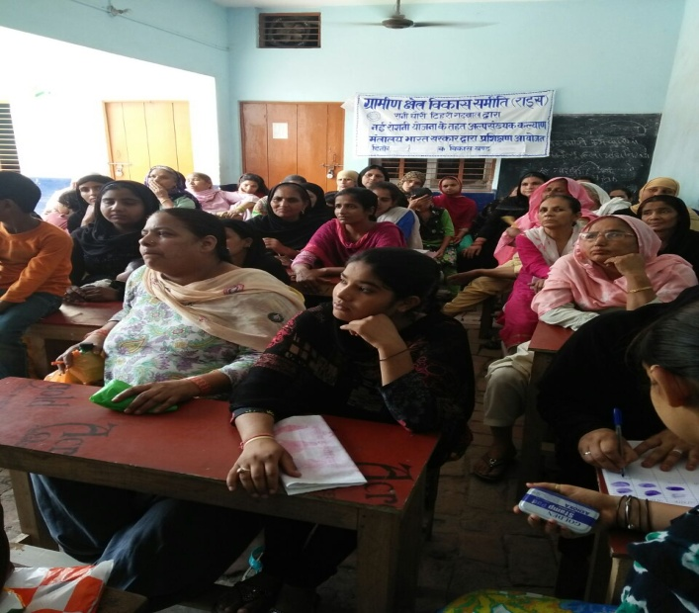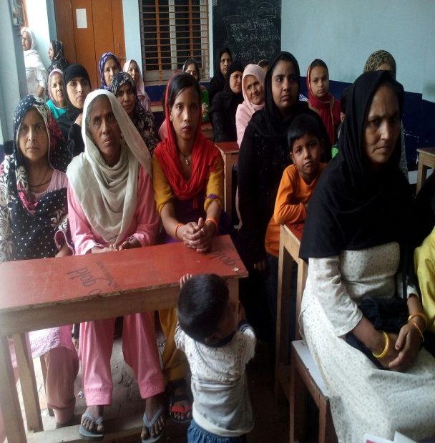
vYila[;d efgyk,sa izf’k{k.k ysrh gqbZ
bl izf’k{k.k ds gksus ls efgykvksa es vkRefuZHkjrk cM+h gSA rFkk efghykvksa es lkekftd tkx:drk vkbZ gSA

u’kk mUeqyu dk;Zdze
laLFkk ds }kjk ;qokvksa es u’kk de gks bldks fy, iqfyl iz’kklu o fof/kd lsok izkf/kdj.k ds ek/;e ls fofHkUu Ldwyks dkyst o ;qokvksa o xkWoksa es tkx:drk vfHk;ku pyk;kx;kA ftles mudks u’ks gksus okys chekfj;ksa rFkk muds mik; ij tkx:drk fd x;hA
- efyu cfLr Vhu 'kSM ckSjkM+h
- lRdkj gksVy pEck
- dkeZy Ldwy pEck
- fo|k efUnj mfu;kylkjh
- jkbdk jkuhpkSjh
- jkbdk pEck
- jkbdk udksV
- izrki b.Vj dkyst ckSjkM+h
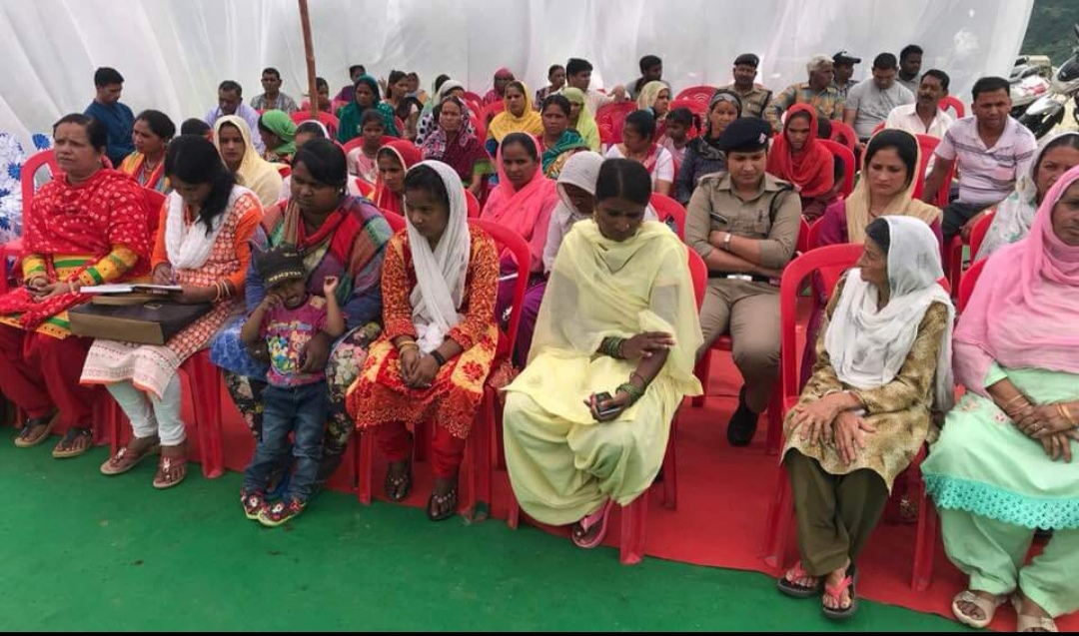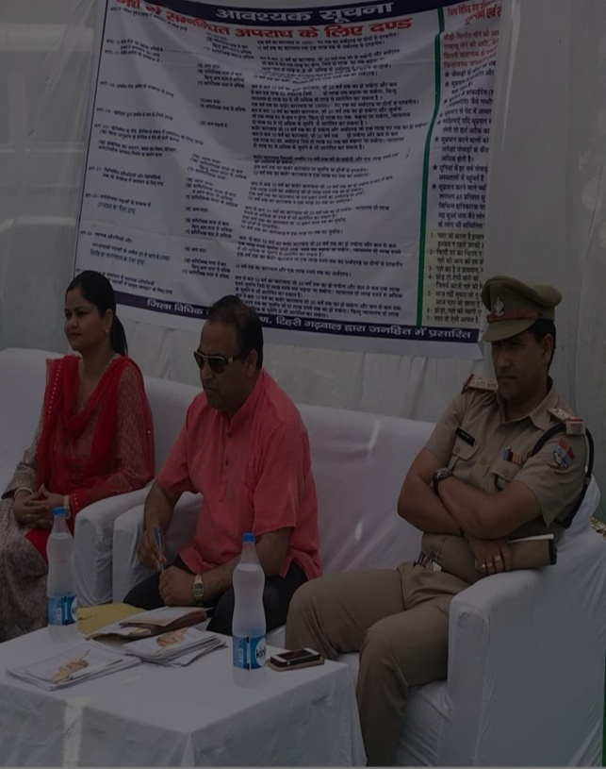
laLFkk ds }kjk fcuk dkWdVsy ikVhZ dh 'kknh vk;ksftr fd x;h ftles dksVh xkao dh euh"kk ds }kjk fcuk dkWdVsy dh 'kknh djus ij rFkk fn[kksy xkao dh liuk ds }kjk fcuk dkWdVsy ikVhZ ds fookg djus ij izksRlkfgr fd;k x;kA ftles izksRlkgu ds :i es 2100 dh /kujkf’k o iz’kfLr i= iz/kku fd;k x;kA xzke xqfu;kV xkWo ds efgykeaxy ny ds }kjk vius xkao es 'kjkc dk fcjks/k djus ij Hkh iq:Ld`r fd;k x;kA

ftyk fnO;kWx iquZokl dsUnz
ftyk fnO;kax iquZokl dsUnz Hkkjr ljdkj ds lkekftd vf/kdkfjrk ea=ky; ds }kjk foriksf"kr gS tks fd ftyk vLirky ckSjkMh es fLFkfr gS ftyk fnO;kax iquZokl dsUnz ds ek/;e ls fnO;kax tuks gsrq xsLV gkml :dus ds fy,ss cuk;k x;k gSA ftles fnO;kax tu fu’kqYd :drs gSaA bl lky 240 fnO;kax tu xsLVgkml es :dsA ftyk fnO;kax tuks dsk bl o"kZ fuEu lkexzh miyC/k djk;h x;hA
dzla | Cykd dk uke | lgk;d lkexzh dk fccj.k
 |  | p’ek | dku dh e’khu | Oghy ps;j | cS’kk[kh | NMh | vU;
01 | pEck | 97 | 28 | 14 | 11 | 21 | 0
02 | ujsUnzuxj | 62 | 05 | 0 | 03 | 01 | 0
03 | fHkyaxuk | 32 | 02 | 03 | 02 | 07 | 0
04 | tk[k.kh/kkj | 23 | 05 | 01 | 01 | 02 | 0
05 | FkkSy/kkj | 62 | 01 | 01 | 01 | 02 | 01iSj
06 | izRkki uxj | 0 | 02 | 06 | 01 | 03 | 02
07 | tkSuiqj | 0 | 01 | 07 | 04 | 03 | 0
08 | nsoiz;kx | 70 | 03 | 0 | 02 | 02 | 0
09 | dhfrZuxj | 0 | 0 | 0 | 0 | 0 | 0
 | dqy | 346 | 47 | 32 | 25 | 41 | 03

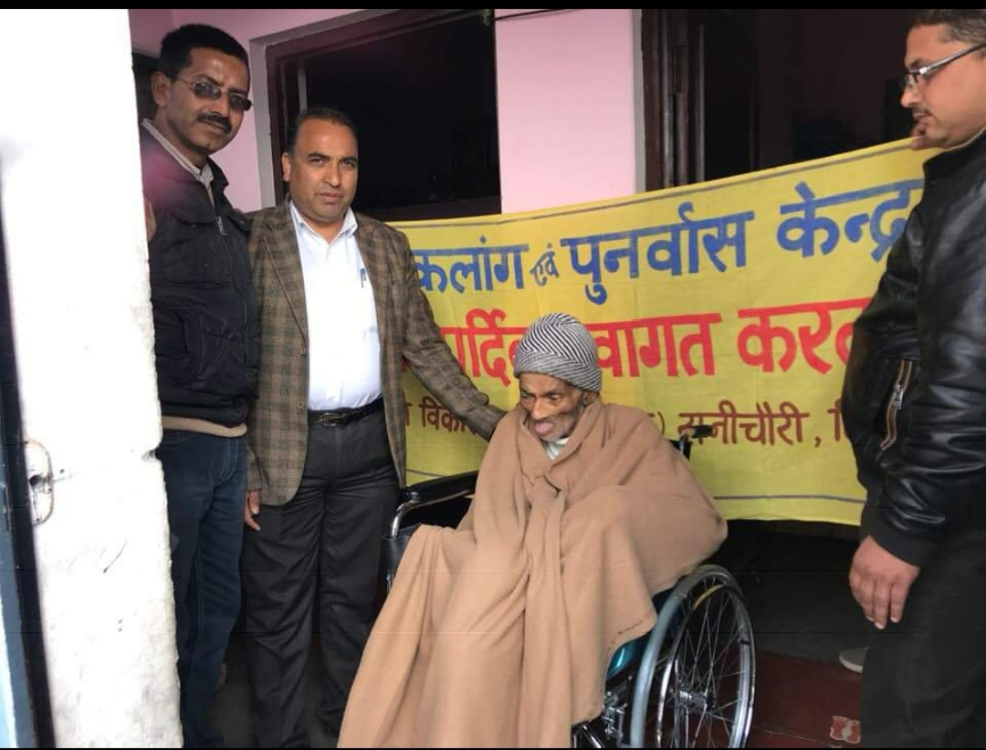
fnO;kax tu dks Oghy ps;j miyC/k djrs gq,s
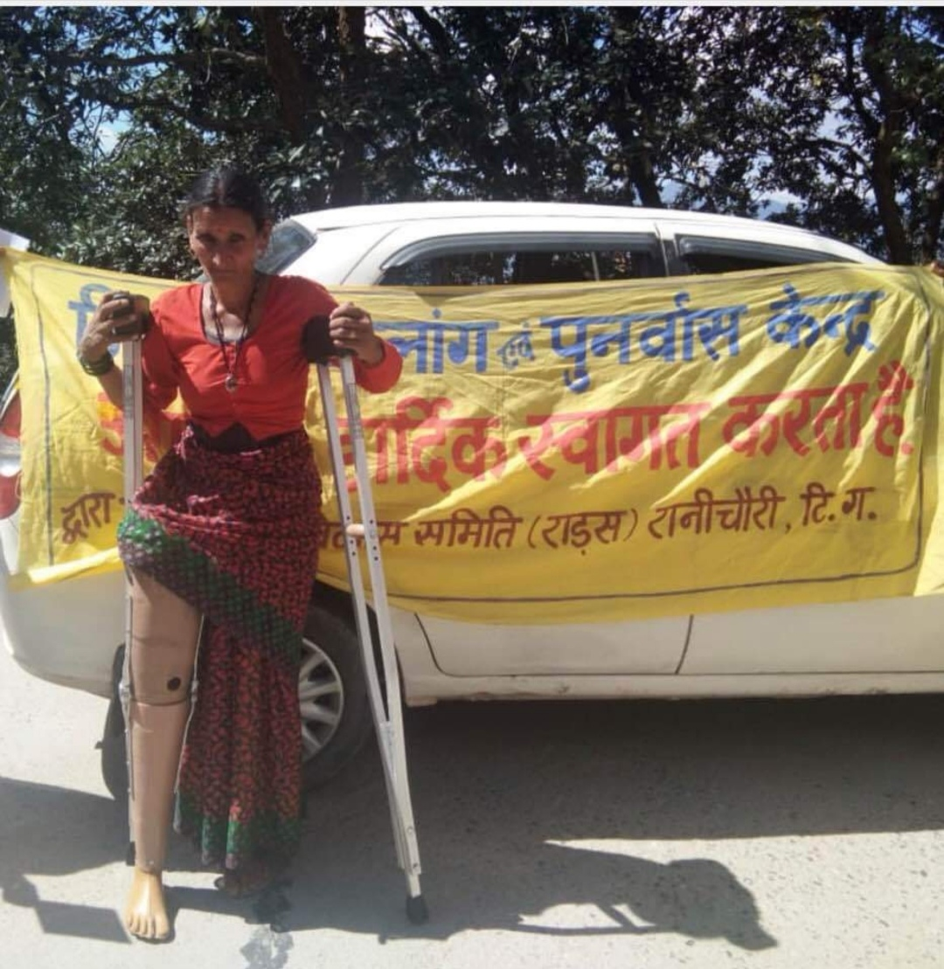
fnO;kWx tu dks d`f=e iSj miyC/k djkrs gq,s
us’kuy VªLV ds lg;ksx ls 15 yhxy xktZu fu;qDr fd x;h gSA ftykf/kdkjh ds ek/;e ls izR;sd rhu ekg es yksdyLrjh; lfefr dh cSBd vk;ksftr fd tkrh gSA ekuuh; lkWln th ds }kjk iq:Ld`r djrs gq,s%

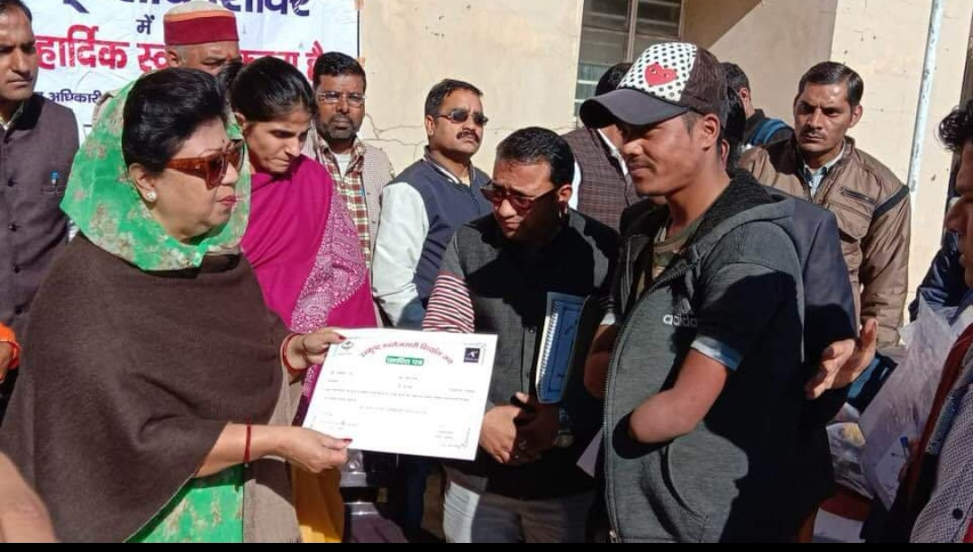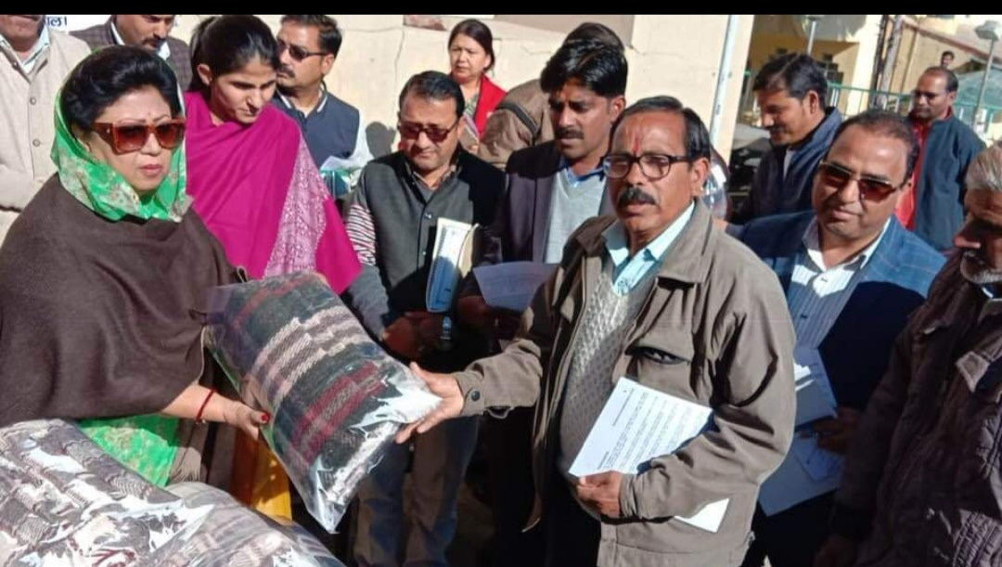

fi= ou dk;Zdze
fi= ou dk;Zdze ds rgr 26 xkaoks es fi= ou yxok;k x;k gSA ftles 02 xkao HkkVwlS.k dksVhxkM es iw.kZ :i ls dk;Z 'kq: gks x;k gSA
xkWo 1-uSy 2- MkxhZ 3- eqM;kxkWo 4- lkcyh 5- xqYMh 6- MMwj 7- iSU;wyk 8- uokxj 9-ikVk 10- fn;wjh 11-L;wVk 12- tkSy 13- lqnkMk 14- /kkSY;k.kh 15- Fkku 16- fn[kksyxkWo 17-eTt;wM 18-pkSif<;kyh 19 pkSif<+;ky xkao 20-pwjsM+/kkj 21- Iykl 22- dVkYMh 23- HkkVwlS.k 24- nkSy 25- xqfu;kVxkao 26- fcMdksV
MkxhZ HkkVwlS.k dksVhxkM fcMdksV o xqfu;kVxkWo us lkoZtfud Hkwfe ij fi=ou dk;Zdze 'kq: fd;k gSA

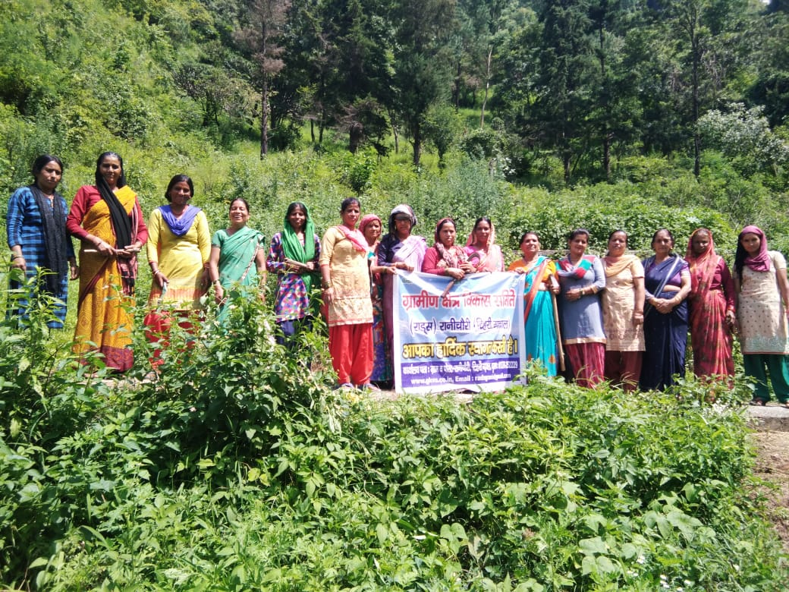

bldk eq[; mnsn’; isMksa dks dSls cpk;k tk; rFkk dSls budk laj{k.k fd;k tk; bl ij fopkj fd;k tkuk pkfg,sA blds rgr laLFkk ds }kjk ;g dk;Zdze es pyk;k x;k gS A blds rgr laLFkk ds fofHkUu xkaoksa es pyk;k x;k gSA

vkftfodk ifj;kstuk%& vYeksMk ds rkMh[ksr o L;kyns Cykd es pyk;h x;h ftldh izxfr bl izdkj gS%&
Federation turnover:
Financial status of the federations in Tarikhet block was established based on the business done under the project and utilization of the received amount in the business of federation and its members.In first year of the project Six federations were set up and has started its business after permission and guidance from District Management unit with a turnover of Rs. 1199651.49 and clear profit of Rs. 127629.23
LC | Turnover (Rs) | 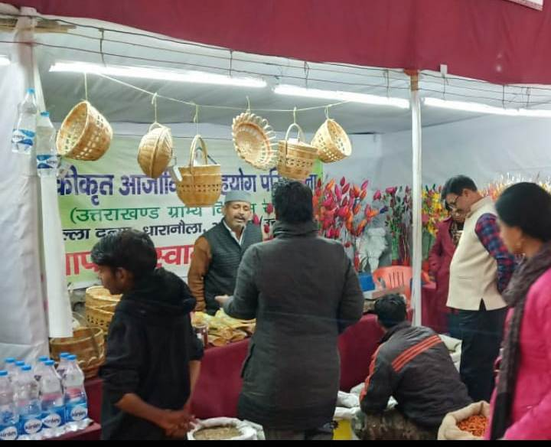  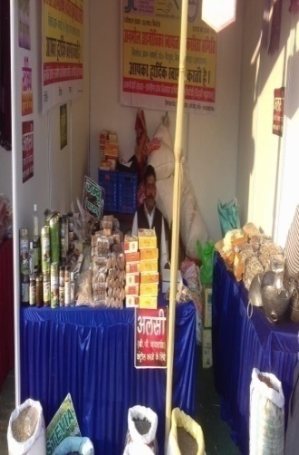  Net Profit (Rs)
Nayi Kranti SRC  Malla Biswa | 281606.89 | 22081.03
Anmol SRC Billekh | 149672.8 | 18576.5
Faldakot SRC Jainoli | 200258.93 | 18672.07
Sherchugaon  SRC Bamsyun | 339018.6 | 37593.9
Nayi Udaan SRC Pipli | 132228.2 | 16653.8
Nayi Shakti SRC  Pantkotali | 96866.07 | 14051.93
6 | 1199651.49 | 127629.23

Establishment of L.D.P.E tanks:
As per the needs of production groups in Tarikhet block and according to the norms of the project, there is development of irrigation tanks in the selected villages for which land was decided by the common agreement of all group members and N.O.C. Under this 75 tanks are developed with additional 5 new tanks are added. Tank costs Rs.43000 of which Rs.36550 is provided by project in two installments and rest Rs.6450 is afforded by the beneficiary.
LC | Tanks | Area (Nali) | 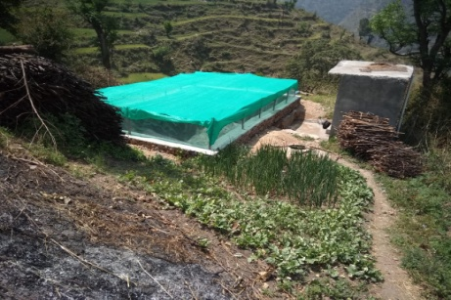  New
Nayi Kranti SRC | 11515155 | 68 | 11515155
Faldakote SRC | 15 | 61 | 15
Nayi Udan SRC | 12 | 44 | 12
Nayi Shakti SRC | 12 | 52 | 12
Anmol SRC | 12 | 57 | 12
Sherchougaon SRC | 14 | 72 | 14
6 | 80 |  | 80
Crop insurance:
Insurance of crops grown by the farmers was done to protect them from sudden losses.Farmers were made aware to protect themselves from economic losses caused.With the help of members of technical institute and analogue department, crops were insured under P.M crop insurance scheme.Under this total 3.52-hectare land crop was insured in tarikhet block.
LC | Village | Groups | Members | Insured Crops |  |  |  | Total Area (Hec.)
 |  |  |  | Lentil in nali | Area | Wheat in nali | Area
Anmol src | 18 | 34 | 55 | 0 | 0 | 642 | 12.84 | 12.84
Sherchaugaon Src | 11 | 18 | 48 | 0 | 0 | 495 | 9.90 | 9.90
Faldakote Src | 3 | 7 | 15 | 0 | 0 | 62 | 1.24 | 1.24
Nayi Udaan src | 1 | 1 | 1 | 0 | 0 | 5 | 0.10 | 0.10
Nayi Kranti Src | 5 | 5 | 5 | 6 | 0.12 | 1 | 0.02 | 0.14
Nayi shakti Src | 3 | 3 | 3 | 0 | 0 | 6 | 0.12 | 0.12
6 | 41 | 68 | 127 | 6 | 0.12 | 1211 | 24.22 | 24.34
Milk collection center:
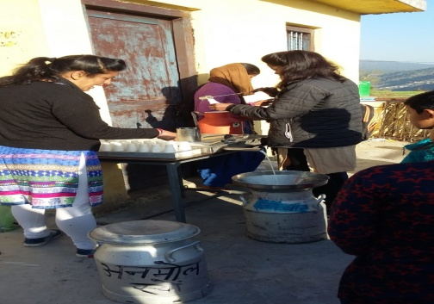
It was set up to sell the milk of beneficiaries of the project area with
support of Uttarakhand livestockdevelopment board and Anchal.
Convergence meeting with the milk producer beneficiarieswere
organized and were informed regarding benefitsof business
incoordination with Anchal and how to increase production by using
vaccination, deworming, animal feed, insuranceand A.I. A total
production of Rs. 33202, 46263 withprofit of Rs. 1660, 1387.89 was
recorded in Faldakote SRc, Anmol Src ofTarikhet block respectively.

LC | Center | Member | Milk (Ltr/Day) | 2018-19
 |  |  |  | Turn Over (Rs) | Profit (Rs) | Profit Ratio
FaldakotSrc | 1 | 40 | 35 | 33202 | 1660 | 4 %
Anmol Src | 1 | 38 | 59.42 | 46263 | 1387.89 | 3%
2 | 2 | 78 | 94.42 | 78465 | 3047.89 | 7%
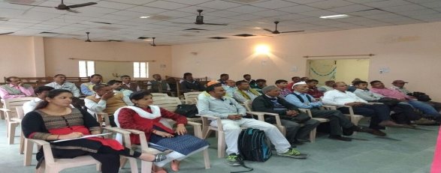
Block level Coordination and Monitoring Committee:
Under this technical agency RADS, along with analogue
department, PanchayatiRaj members and federation
members every trimester block level meetingis organized
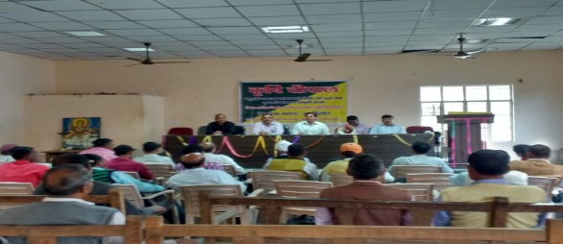
to acknowledge the departmental officers of Tarikhet block.
Trim. | Date | Place | Member | Chair Person
1 ST | 27-12-18 | Block Hall | 30 | Block Pramukh

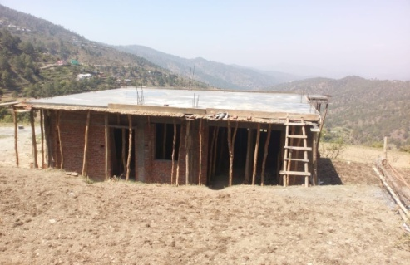
Collection centre:
These centers were developed with an aim to collect the
products from village level small collection centers and
after proper grading and packaging to be marketed.
1nali land was taken by federation in lease for 30 years from the
village member.This yearFaldakote SRc,Nayi Kranti Src,Anmol Src,
collection center’s construction is Approximately completed
while Nayi Shakti Src, Sherchaugaon SRCs of Tarikhet block is in
Work in progress.

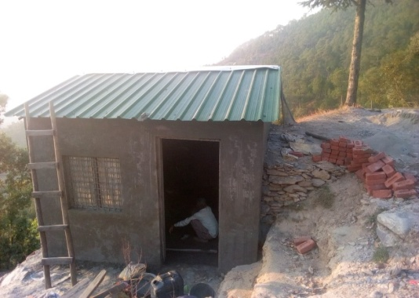
Mini collection centre:
For collection of products within 5-6 villages one
mini collection center is formed for easy collection of products
and after proper packaging to be sold in the market.0.5nali land
was taken by federation in lease for 10 years from the village
members of Tarikhet block. As perthe norms, small collection
centre of 10 *12 sq.ft.

Fallow land:
It is aimed to make the group members economically stronger by establishing a large fruit orchard.As per the directions and agreement, fruit orchard in 5 hectare land is developed by providing a total amount of each unit Rs.127500 in 2 terms by project and Rs.22500/- by federation.For this pit of 1 m² and inter-plant space of 10 m for groundnut and 0.5 m² with inter-plant space of 5 m for other plants is fixed. At Tarikhet blockat total of 6348 plants are sown in 2018-19.
LC | Area (Hec) | Village | 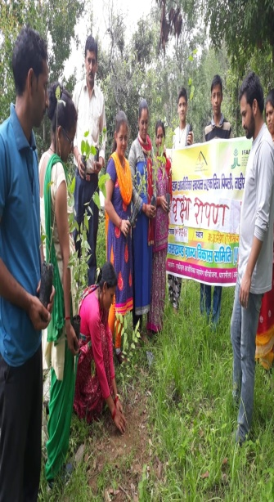  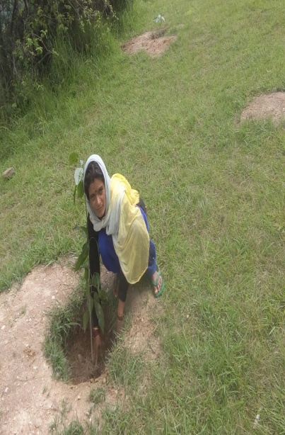  Fruit Plants sowed
Nayi kranti src(malla vishwa) | 5 | 3 | 980
Faldakote src(jainoli) | 5 | 2 | 1118
Sherchaugaon src(bamshyun) | 5 | 3 | 1022
Nayi udan src(pipali) | 5 | 3 | 1139
Nayi shakti src(pantkotuli) | 5 | 3 | 1066
Anmol src (billekh) | 5 | 4 | 1023
6 | 30 | 18 | 6348
Establishment of animal fodder grass cluster:
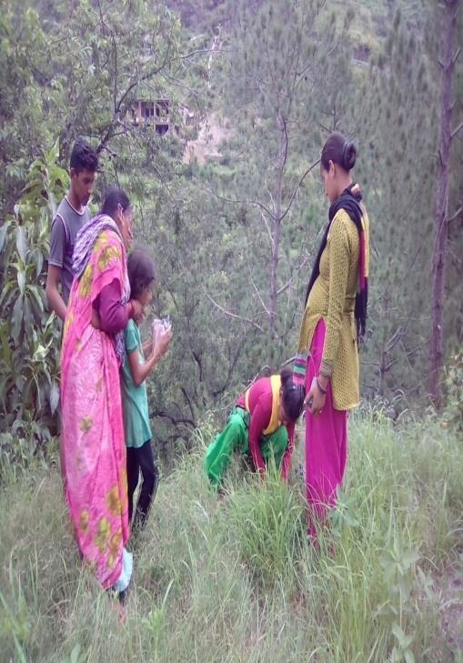
It was established with the aim to fulfill the fodder requirement of animals of the selected workspace round the year.For this Napier fodder grass And Fodder plants from Mahima fal Ewam Chara Podhalaya is purchased for which financial support of Rs.42500/- per federation is given by the project and rest Rs.7500/- by the federation itself.
LC | Area  (He) | Village | Plantation
 |  |  | Nap (Q) 18-19 | FodTree 18-19
Nayi kranti src(malla vishwa) | 5 | 4 |  | 500
Faldakote src(jainoli) | 5 | 1 |  | 1000
Sherchaugaon src(bamshyun) | 5 | 2 | 35 QTL. | 500
Nayi udan src(pipali) | 5 | 3 | 35 QTL. | 500
Nayi shakti src(pantkotuli) | 5 | 3 | 35 QTL. | 500
Anmol src (billekh) | 5 | 4 | 35 QTL. | 500
6 | 30 | 17 | 140 | 3500
Area
Chain link fencing:

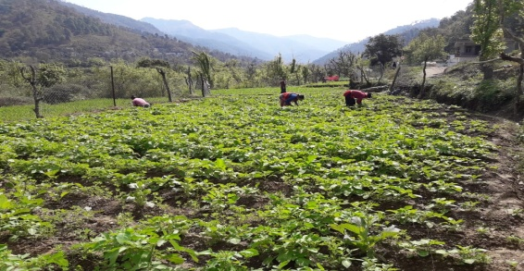
This is done to protect crop from damage caused by wild animals and to increase income from the income so gained. Under this chain link fencing of 1170 m per federation is purchased Thrice for which Rs.248508 is provided by the project and rest by the federation itself.
LC | Village | Area (Nali) | Bundles | Length  (R/M) | Duration  (M) | Rent (Rs) | Sale (Rs)
Nayi kranti src(malla vishwa) | 12 | 29 | 234 | 2820 | 6 | 37440 | -
Faldakote src(jainoli) | 8 | 57.5 | 230 | 3450 | 6 | 36720 | -
Sherchaugaon src(bamshyun) | 7 | 59 | 234 | 2820 | 6 | 37440 | 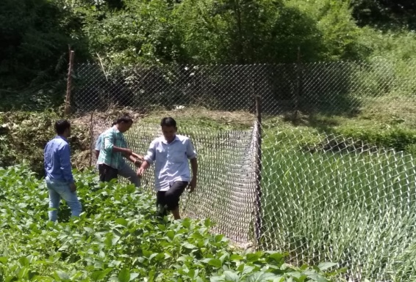  -
Nayi udan src(pipali) | 1 | 18 | 234 | 2340 | 6 | 37440 | -
Nayi shakti src(pantkotuli) | 7 | 27.5 | 234 | 1965 | 6 | 37440 | -
Anmol src (billekh) | 9 | 67.5 | 234 | 3510 | 6 | 37440 | -
6 | 44 | 258.5 | 1400 | 16905 | 6 | 223920 | -

Seed distribution:
The established productive group members were provided technical information regarding enhanced variety of seeds and plants. Thus, as per the needs seeds of ginger, Potato, radish, and turmeric were distributed.
Activities | Village | Group | Member | Quan/No. | Department
Polyhouse | 3 | 3 | 3 | 3 | Horticulture,tarikhet
Syahi Hal | 2 | 2 | 2 | 2 | Agriculture,Bamshyun
Crop Insurance | 30 | 57 | 127 | 127 | Agriculture, Tarikhet
Vermi Pit | 1 | 1 | 7 | 7 | Agriculture, Tarikhet
Wheat Seed | 4 | 6 | 21 | 223 | Agriculture, Tarikhet
Lentil Seed | 1 | 2 | 4 | 4 | Agriculture, Almora
Turmeric Seed | 16 | 10 | 57 | 100 | Horticulture, Tarikhet
Cattle Vaccination | 1 | 4 | 20 | 46 | Animal Husbandry
Gosala Renovation | 7 | 8 | 8 | 8 | Animal Husbandry
Jayi Seed | 9 | 21 | 83 | 425 | Animal Husbandry
Baerseem Seed | 4 | 5 |  |  | Animal Husbandry
Chicks Distribution | 8 | 6 | 77 | 551 | Animal Husbandry
Cheery and maize | 6 | 18 | 90 | 120 | Animal Husbandry
Hand Spray | 2 | 2 | 14 | 4 | Horticulture, Bamshyun

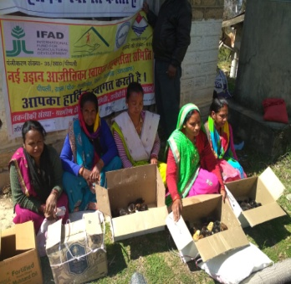
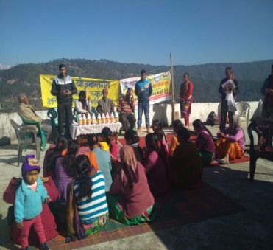
Convergence with line department:

The established production groups were provided
information regarding beneficial schemes developed
by the govt. through facilitators of RADS
technical institute at village and cluster level.
Information regarding farm machinery, seeds,Chicks
Distribution,vaccination, deworming, insurance
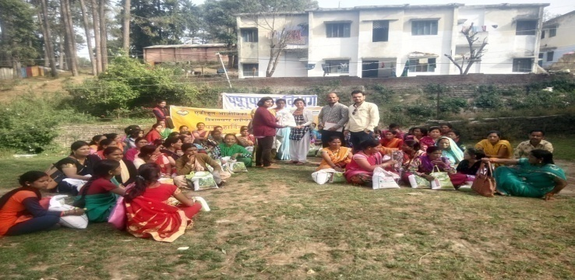
were given.

Vocational training program:
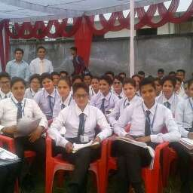
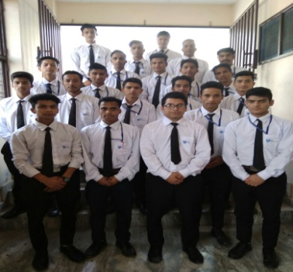
Within I.L.S.P. the unemployed and volunteer male
and female candidates were trained and linked
with employment. Under ILSP , 60 youths Students
were trained in Hotel management courseFrom
haldwani and sauni Hotel management Institute
With Courses front Office,Servicing,Cook Etc.

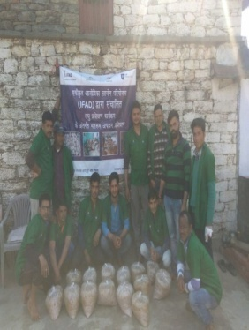
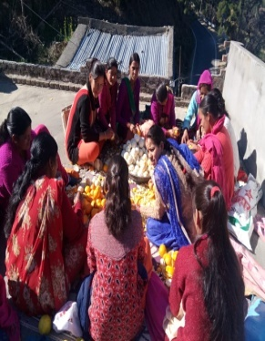
Voluntary business training program:
Within I.L.S.P. the unemployed and volunteer male and
female candidates were trained and linked with employment.
Under these, 35 women 12 man were trained by Horticulture
And fruit processing Center produce juice,pickleAnd mashroom
Produce Traning under ILSP in Tarikhet.

Work done by technical institution in financial year2018-19
1-Food security and livelihood grouth-The food security and livelihood enhanchment five manufacturing groups were formed in the financial year 2018-2019 in the syalde block which has 80% women,their details,
1-Under the integrated livelihood cooperation project how many village are there through technical agencie RADS and how many groups members GEN,SC,OBC are there.

s.no | No of village | No of group | Total members | GEN | SC | OBC
1 | 121 | 371 | 3566 | 3069 | 351 | 146

2-Group saving and meeting- 371 group meeting are being regularized by the project workers and their regular saving have also been increased financial transactions are also being done through the saving made by the group, which is used by the members of the group to fulfill their domestic needs childrens fees are being made for cattle farming which are as follws,
Financial year | Total groups | Cum saving (Rs ) | Cum Loan (Rs) | Cum returm (Rs)
2018-2019 | 371 | 11067895 | 5926081 | 2596502

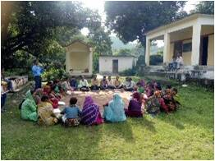
3- Under the integrated livelihood cooperation project six(6) federation have been set up by the technical institution RADS SYALDE which are being bod meetings and three committee meeting every month,
S.no | Src name | Bod meeting date every month | committe
1 | Maakalinkasrcgudlekh | 10 | 3
2 | Nayijagritisrckalyanpur | 9 | 3
3 | Naiummedsrcpaithana | 5 | 3
4 | Choukotvikassrcmaghyari | 8 | 3
5 | Devbhoomisrcbharsoli | 2 | 3
6 | Kissanjagritisrcgolna | 7 | 3
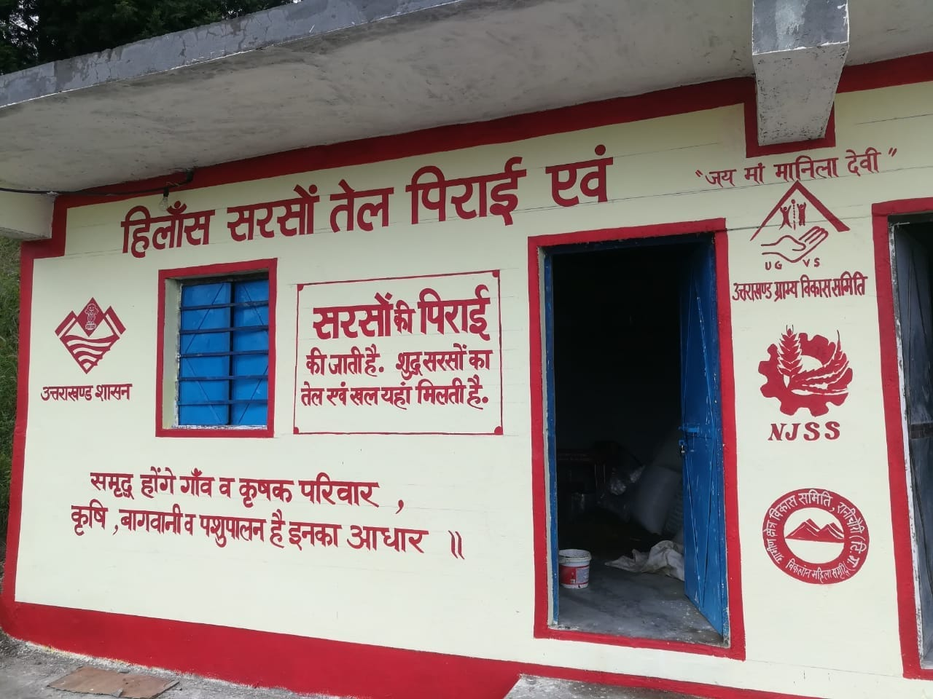
Other Activities- It has also been given the attention of the federation by the federation for the purpose of earning by the institution RADS,ILSP in block syalde, in which the oil unit canteen, dairy production etc,
- Oil unit- The mustard is collected by the groups members and seat to the oil unit and the mustard oil is produced wich is know as the HINLASH MUSTARD oil this new awakening is being done by the nayejagritisrckalyanpur block syalde,
S NO | NAME OF LC | investment | Total turn over | Total profit | Oil rate
1 | Naijagritsrckalyanpur | 60500 | 72000 | 11500 | 120/lt

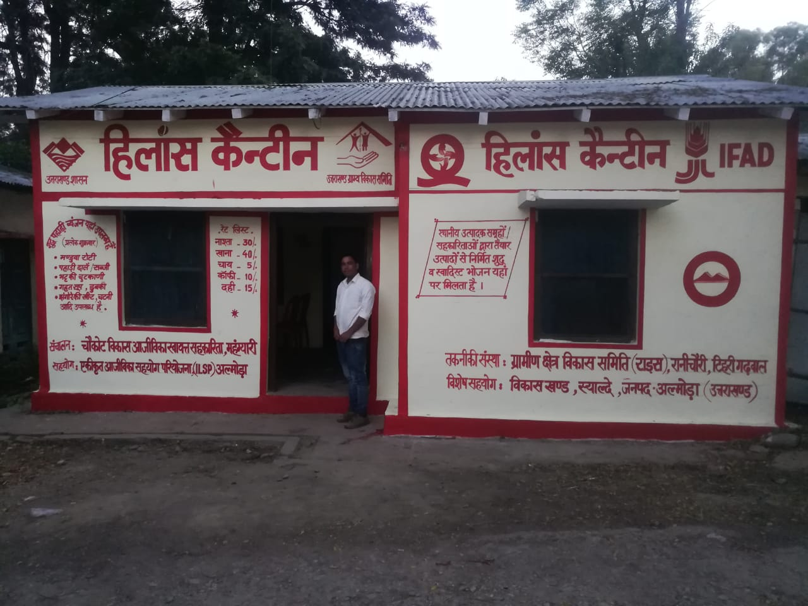
B-Canteen- The restourent has been established by choukotvikassrc, which is located in the premises of the block office in which pure local dish is prepared and people of local dishes enjoy the name of HILANS CANTEEN famously in block syalde,

S. no | Name of lcs | investment | Total turn over | profit
1 | Choukotvikassrcmaghyari | 74524 | 132281 | 66304

c. Daliya unit-
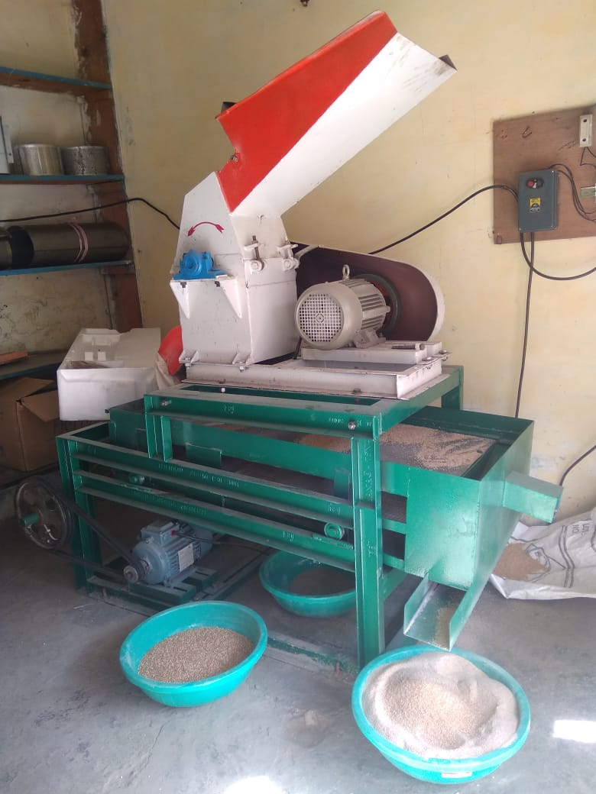
S.NO | NAME OF LCS | INVESTMENT Equipments | investment | Total turn over | profit
1 | Maakalinkasrcgudlekh | 207000 | 33000 | 45000 | 12000

Turn over-Under the project in the financial year 2018-19 a local utility business is carred out in the value chain by the federation in the syalde block in which the income of the members of the group in increasing and the identity of the federation is becoming an identity,

All src business 2018-2019
LC NAME | TOTAL INVESTMENT | TOTAL TURNOVER | TOTAL PROFIT
Maakalinkasrcgudlekh | 848719 | 944435.5 | 95716.5
Nayijagritisrckalyanpur | 354299 | 390233 | 35934
Naiummedsrcpaithana | 538319 | 621812 | 58997
Choukotvikassrcmaghyari | 654393 | 740996 | 96603
Devbhoomisrcbharsoli | 483116 | 535758.3 | 56220.8
Kissanjagritisrcgolna | 337317.5 | 429841.5 | 44565
TOTAL | 3216163.5 | 3663076.3 | 388036.3

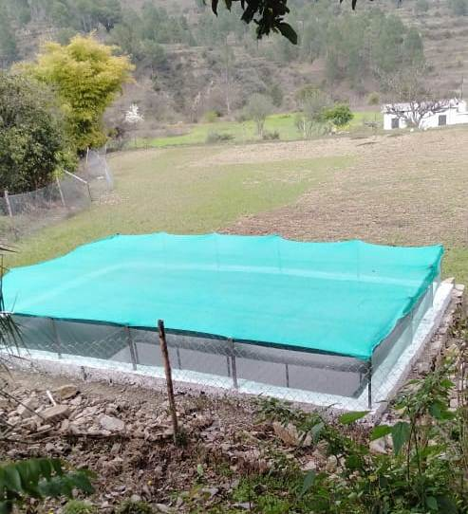
4-LDPE TANK-Total ldpe tank are 120 in block syalde and 31 modern ldpe tank and us are 45 tank renewation,
These are used in the form of irrigation of farms,excessive raining water is collected and used in irrigation sheedplantation,nursery,fishingetc,

LC | TANKS | AREA NALI | RENOVATED | NEW
Maakalinkasrcgudlekh | 20 | 50 | 11 | 6
Nayijagritisrckalyanpur | 20 | 65 | 6 | 4
Naiummedsrcpaithana | 20 | 55 | 11 | 6
Choukotvikassrcmaghyari | 20 | 60 | 7 | 6
Devbhoomisrcbharsoli | 20 | 70 | 8 | 5
Kissanjagritisrcgolna | 20 | 72 | 2 | 4

5- Mini collection center- Through the project a total of 18 mini collection centers have been set up in the financial year 2018-19 syalde block which is used by the group in production grading packaging,

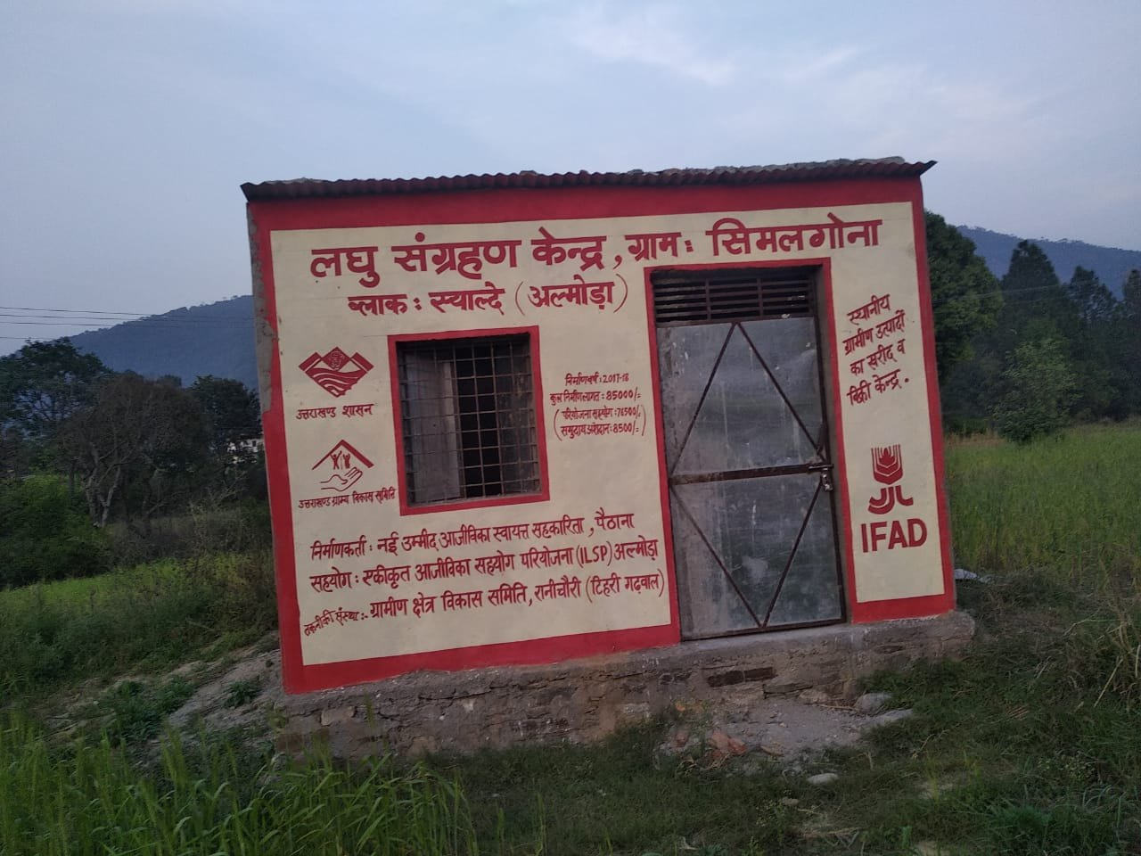
LC NAME | VILL | 2018 MINI COLLECTION CENTER | 2019-2020
Maakalinkasrcgudlekh | GUDLEKH | 1 | 1
Nayijagritisrckalyanpur | KALYANPUR | 2 | 2
Naiummedsrcpaithana | PAITHANA | 3 | 0
Choukotvikassrcmaghyari | MAGHYARI | 3 | 0
Devbhoomisrcbharsoli | BHARSOLI | 1 | 1
Kissanjagritisrcgolna | GOLNA | 4 | 0

6-Collection center-Under the project 4 collection centers of financial year 2018-2019 are being utilized by the federation to grading packaging of the local product,

Src name | Cluster name | No of collection center | Gprs
Kissanjagritisrcgolna | GOLNA | 1 | N-29’55.670  E-79’14.119  H-1045M
Choukotvikassrcmaghyari | MAGHYARI | 1 | N-29’80.07  E-79’02.18  H-922M
Naiummedsrcpaithana | PAITHANA | 1 | N-29’82.69  E-79’20.44  H-849M
Devbhoomisrcbharsoli | BHARSOLI | 1 | N-29’90.03  E-79’22.04  H-945M

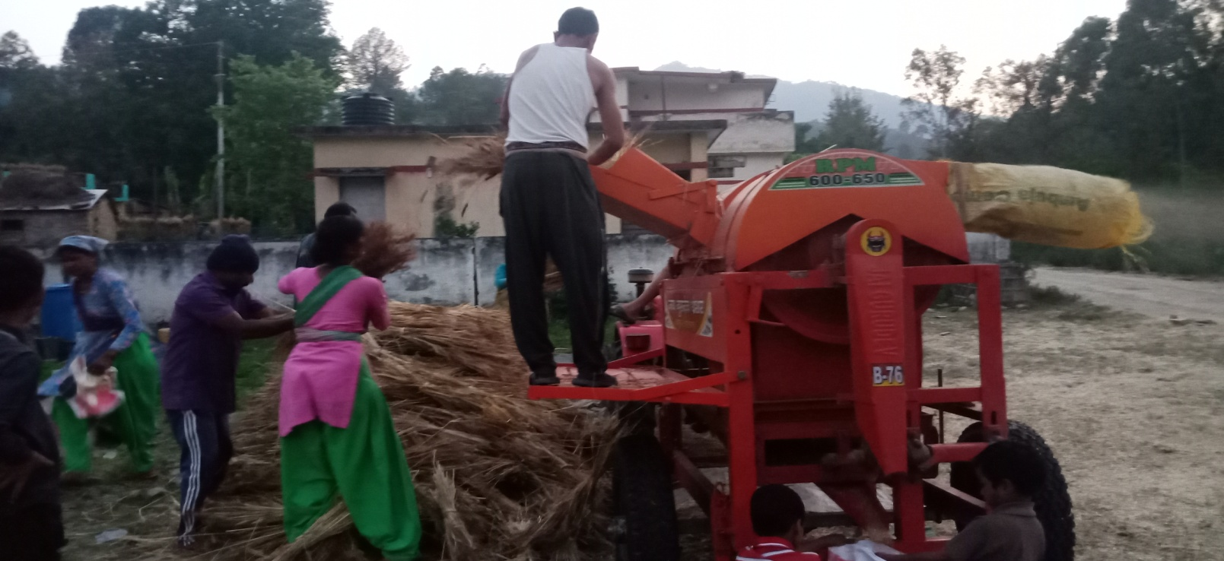
7-Farm machinery bank-Farm machinery bank under the scheme ,six farm machinery bank have been set up by six federations in the syalde block through the agriculture department in which it is also being used by the federation and its rent is also being taken the federation and women there also a decrease in the functioning of food time is also being saved,

s.no | Block name | Src name | Cluster | Total investment | subside | Net profit | Recived rent | H H | AREA NALI
1 | syalde | Naiummedsrcpaithana | Paithana | 643412 | 514730 | 128682 | 8500 | 127 | 131
 |  | Devbhoomisrcbharsoli | Bharsoli | 708012 | 56690 | 651322 | 3600 | 108 | 135
 |  | Choukotvikassrcmaghyari | Maghyari | 708012 | 56690 | 651322 | 4500 | 112 | 165
 |  | Naijagritisrckalyanpur | Kalyanpur | 643412 | 514730 | 128682 | 6000 | 101 | 96
 |  | Kissanjagritisrcgolna | Golna | 643412 | 514730 | 128682 | 5800 | 141 | 121
 |  | Maakalinkasrcgudlekh | Gudlekh | 643412 | 514730 | 128682 | 6500 | 131 | 147
 |  | total |  | 3989672 | 2172300 | 1817372 | 34900 | 720 | 795
 |  | grand total |  | 3989672.00 | 2172300.00 | 1817372.00 | 34900 | 720 | 795

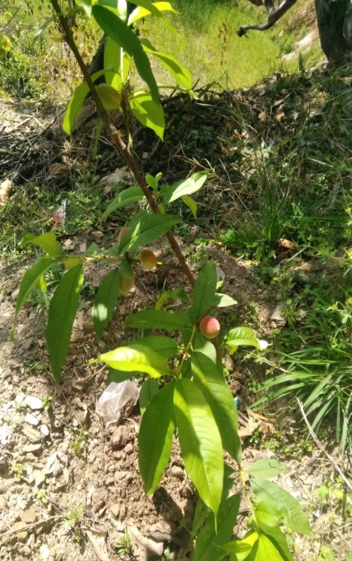
8- Fellow land- syalde block in financial year 2018-19 the work of fellow land was curried out in the federation 250 nali drains to produce crop production in waslelands in which 127500by the federation and 22500 contribution,
s.no | Src name | village | MSL ¼m½ | Area nail | citrus | gauva | linchi | JACKFRUIT | mango | awala | total
1 | Maakalinkasrcgudlekh | mishrkhola | 1387 | 250 | 554 | 0 | 0 | 312 | 155 | 0 | 1021
2 | Devbhoomisrcbharsoli | patharkhola | 918 | 250 | 554 | 150 | 50 | 156 | 156 | 0 | 1066
3 | Naijagritisrckalyanpur | juniyagari | 1901 | 250 | 1020 | 0 | 0 | 0 | 0 | 0 | 1020
4 | Choukotvikassrcmaghyari | Arrirajwar ,timiltanola,agaspur | 830 | 250 | 277 | 0 | 0 | 0 | 312 | 554 | 1143
5 | Naiummedsrcpaithana | Timli ,walmara | 899 | 250 | 277 | 0 |  | 468 | 156 | 0 | 901
 | total |  |  | 1250.00 | 2682 | 150 | 50 | 936 | 779 | 554 | 5151

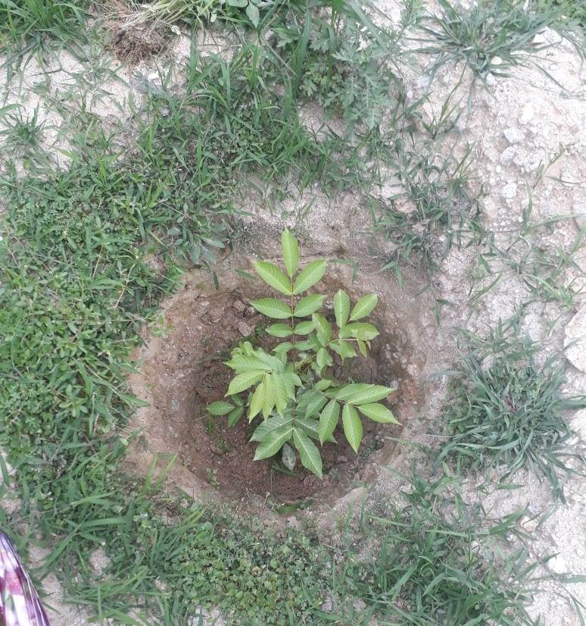
FELLOW LAND GAFF FELLING 2017-2018
S.NO | SRC NAME | VILLAGE NAME | NALI | WALNUT, | PEACH | TOTAL PLANT
1 | CHOUKOT VIKAS MAGHYARI | AGASPUR | 250 | 500 | 350 | 850
2 | MAA KALINKA GUDLEKH | MISERKHOLA | 250 | 500 | 250 | 750
3 | KISSAN JAGRITI GOLNA | KAFALGAIR | 250 | 500 | 300 | 800
total |  |  | 750 | 1500 | 900 | 2400

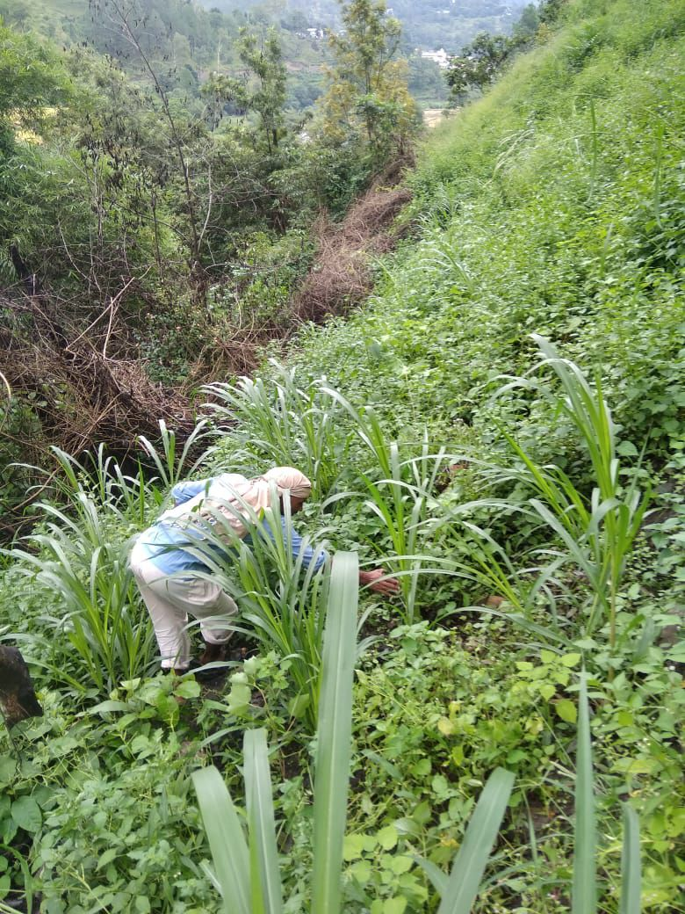
9-Fodder-Under the project through the technical institution the fodder activity has been set up in the barren land by the three federation in the syalde block which is increasing the milk production in which 42500 project have been spent and 7500 federations have been spent by the federation

s.no | Src name | Area nali | Village | Grass name
1 | Devbhoomisrcbharsoli | 250 | 1 | Nepiyar,bhimal
2 | Choukotvikassrcmaghyari | 250 | 2 | Nepair, bhimal
3 | Naijagritisrckalyanpur | 250 | 1 | Nepair ,

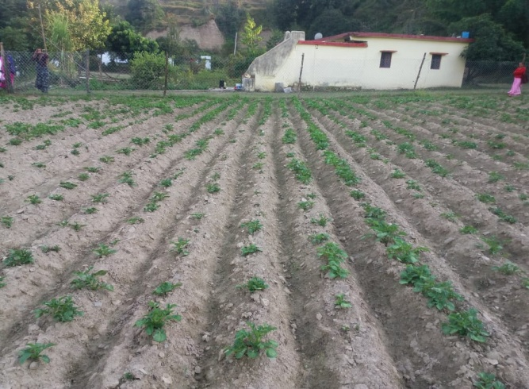

10-Fancing-To avoid the loss of wild animals in block syalde 21102 rm,38 villages used in fencing and cover 496 nali in the train and the fare is also being taken by the federation,

s.no | Block name | Src name | R M | PROJECT SUPPORT | RECIVED RENT | VILLAGE | PG GROUP | HH | AREA NALI
1 | syalde | Naiummedsrcpaithana | 3517 | 735000 | 17565 | 9 | 23 | 157 | 38
 |  | Devbhoomisrcbharsoli- | 3517 | 735000 | 26910 | 8 | 25 | 105 | 42
 |  | Choukotvikassrcmaghyari | 3517 | 735000 | 20417 | 12 | 19 | 138 | 39
 |  | Naijagritisrckalyanpur | 3517 | 735000 | 24972 | 10 | 19 | 148 | 46.5
 |  | Kissanjagritisrcgolna | 3517 | 735000 | 32526 | 14 | 23 | 93 | 51
 |  | Maakalinkasrcgudlekh | 3517 | 735000 | 34374 | 12 | 21 | 127 | 38
 |  | TOTAL | 21102 | 4410000 | 156764 | 65 | 130 | 768 | 254.5

Vocational traning- Under the integrated livelihood cooperation project, training was covlvcted in different types of trades by the agencie in vocational training and a job was also given after course,
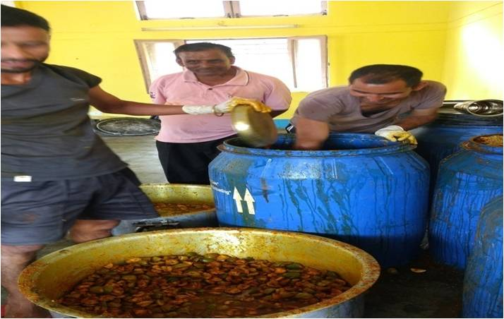
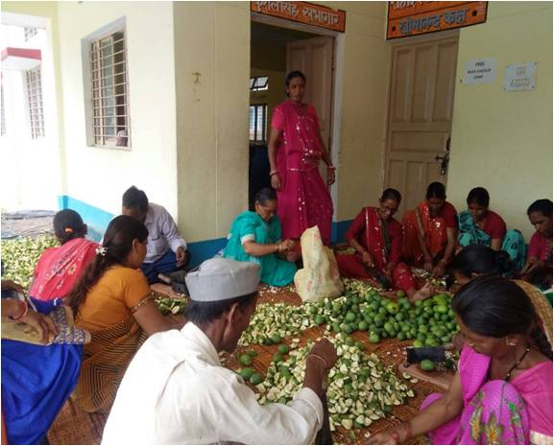
Food preservation-Auxiliary framing (food presenvation) was given to 30 members by farmer awareness federation from syalde block by which members of the group learned the pickle training,jam jelly training,juice training and sold in local market and gave the net profit to the federation,

Convergence- Under the project the benefit was giver to the scheme of member of the croup from the government and non government department in the syalde development block as for the machinery, seed,manure thrower machine,fish pond, immunization,hdpe pipe, fruit plants, manregaetc,

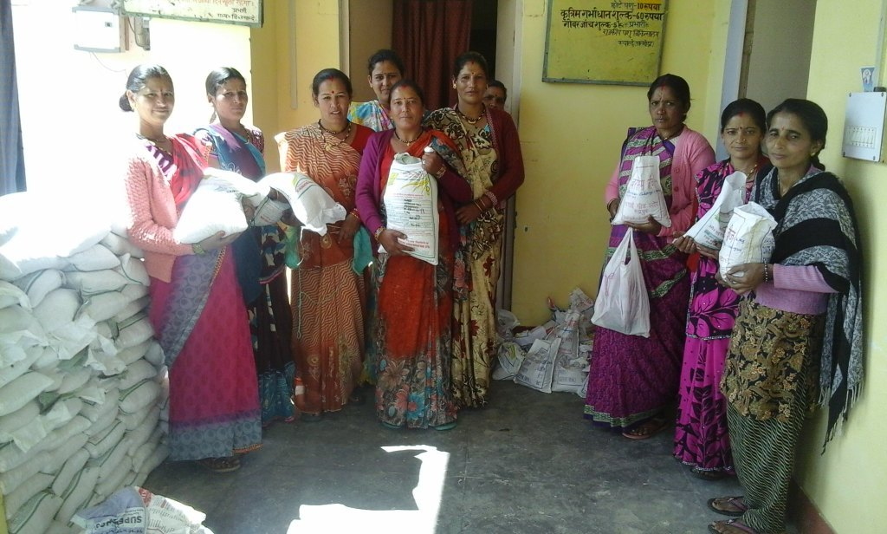

s.no | Groups name | Activity | village | members | department | total | no
1 | Buras pg | Seed | Buraspani | 19 | agriculture | 160 | 20pkt
2 | Maakalinkashg | Seed | Mathkhani | 5 | agriculture | 100 | 5pkt
3 | Jagritipg | Seed | Mathkhani | 17 | agriculture | 200 | 10pkt
4 | Bhumiyapg | Seed | Bajarkhola | 17 | agriculture | 200 | 10pkt
5 | Maabhagwatipg | Seed | Gognayari | 10 | agriculture | 460 | 4pkt
6 | Samridhishg | Cowsheed | Kaihargaon | 5 | Animal husbandry | 1lacs | 1
7 | Ujjwalapg | Cowsheed | Bhakuratalla | 11 | Animal husbandry | 1lacs | 1
8 | Jai durgepg | Cowsheed | Kaihargaon | 9 | Animal husbandry | 1lacs | 1
9 | Jai bhumiyashg | Compost pid | Kaljheepajoshi | 13 | Animal husbandry | 4500 | 1
10 | Guru gorakhnathpg | Compost pid | Kaljheepajoshi | 9 | Animal husbandry | 4500 | 1
11 | Jyotipg | Compost pid | Kaljheepajoshi | 7 | Animal husbandry | 4500 | 1
12 | Bhumiyadevtapg | Fishtank,pollyhouse | Kafalgair | 6 | horticulture | 1lacs | 1
13 | Jai nandapg | Atta chakki,maduwatherser | bharsoli | 9 | agriculture | 1lacs | 3
14 | Narnkardevtapg | Warmi compost | Bharsoli | 9 | agriculture | 4500 | 4
15 | Sangampg | Warmi compost | Bharsoli | 16 | agriculture | 4500 | 6
16 | Parwatipg | Warmi compost | Lalngari | 7 | agriculture | 4500 | 7
17 | Jai nandapg | Warmi compost | Bharsoli | 9 | agriculture | 4500 | 3

